

Predicting Customer Churn in Telecom Industry

[Document subtitle]



Presented

by

Preeth A[MB25]

1. **Introduction**
2. **Dataset over view:**
3. **Tools I Used:**

**4. Data Preparation Steps**

1. **Importing the Data:**
2. **Data cleaning in mysql:**
3. **Extract the dataset in csv format and save in the local folder**
4. **Data visualization**
5. **Table creation:**

* **Measure**
* **Service table**
* **Maping Age group**
* **Tenure Group Table**

**2. Data Modelling**

**3. Visualization**

1. **Index**
2. **Summary page**
3. **Customer Demographics**
4. **Account Details**
5. **Customer Subscription**
6. **Conclusion**
7. **Recommendation**

**1. Introduction**

**Project Overview**: An analysis of customer churn in the telecom industry.

**2. Dataset over view:**

The dataset contains the following columns:

1. CustomerID
2. Gender
3. Age
4. Married
5. NumberOfDependents
6. City
7. ZipCode
8. Latitude
9. Longitude
10. NumberOfReferrals
11. TenureInMonths
12. Offer
13. PhoneService
14. AvgMonthlyLongDistanceCharges
15. MultipleLines
16. InternetService
17. InternetType
18. AvgMonthlyGBDownload
19. OnlineSecurity
20. OnlineBackup
21. DeviceProtectionPlan
22. PremiumTechSupport
23. StreamingTV
24. StreamingMovies
25. StreamingMusic
26. UnlimitedData
27. Contract
28. PaperlessBilling
29. PaymentMethod
30. MonthlyCharge
31. TotalCharges
32. TotalRefunds
33. TotalExtraDataCharges
34. TotalLongDistanceCharges
35. TotalRevenue
36. CustomerStatus
37. ChurnCategory
38. ChurnReason

**3. Tools I Used:**

**MySql**

**Power BI**

**4. Data Preparation Steps**

1. **Importing the Data:**

The first thing I was download the dataset, which were available in CSV format I import the dataset into the MySql data source

* Create the data base for the dataset
* Create the table named as customer churn

1. **Data cleaning in mysql:**

I used these queries for cleaning the data base

1. **Extract the dataset in csv format and save in the local folder**

|  |
| --- |
| 1. select * from customer_churn; 2. ALTER TABLE customer_churn 3. CHANGE COLUMN `Customer ID` CustomerID varchar(30), 4. CHANGE COLUMN `Gender` Gender VARCHAR(50), 5. CHANGE COLUMN `Age` Age INT; 6. #change the column name without space 7. ALTER TABLE customer_churn 8. CHANGE COLUMN `Married` Married varchar (30), 9. CHANGE COLUMN `Number of Dependents` NumberOfDependents INT, 10. CHANGE COLUMN `City` City VARCHAR(100), 11. CHANGE COLUMN `Zip Code` ZipCode int, 12. CHANGE COLUMN `Latitude` Latitude DECIMAL (10, 6), 13. CHANGE COLUMN `Longitude` Longitude DECIMAL (10, 6), 14. CHANGE COLUMN `Number of Referrals` NumberOfReferrals INT, 15. CHANGE COLUMN `Tenure in Months` TenureInMonths INT; 16. ALTER TABLE customer_churn 17. CHANGE COLUMN `Offer` Offer VARCHAR (30), 18. CHANGE COLUMN `Phone Service` PhoneService VARCHAR(255), 19. CHANGE COLUMN `Avg Monthly Long Distance Charges` AvgMonthlyLongDistanceCharges DECIMAL(10,2), 20. CHANGE COLUMN `Multiple Lines` MultipleLines VARCHAR(255), 21. CHANGE COLUMN `Internet Service` InternetService VARCHAR (255), 22. CHANGE COLUMN `Internet Type` InternetType VARCHAR(255), 23. CHANGE COLUMN `Avg Monthly GB Download` AvgMonthlyGBDownload int, 24. CHANGE COLUMN `Online Security` OnlineSecurity VARCHAR (255), 25. CHANGE COLUMN `Online Backup` OnlineBackup VARCHAR (255), 26. CHANGE COLUMN `Device Protection Plan` DeviceProtectionPlan VARCHAR (255), 27. CHANGE COLUMN `Premium Tech Support` PremiumTechSupport VARCHAR (255), 28. CHANGE COLUMN `Streaming TV` StreamingTV VARCHAR (255), 29. CHANGE COLUMN `Streaming Movies` StreamingMovies VARCHAR (255), 30. CHANGE COLUMN `Streaming Music` StreamingMusic VARCHAR (255), 31. CHANGE COLUMN `Unlimited Data` UnlimitedData VARCHAR (255), 32. CHANGE COLUMN `Contract` Contract VARCHAR (255), 33. CHANGE COLUMN `Paperless Billing` PaperlessBilling VARCHAR (255), 34. CHANGE COLUMN `Payment Method` PaymentMethod VARCHAR (255), 35. CHANGE COLUMN `Monthly Charge` MonthlyCharge DECIMAL (10,2), 36. CHANGE COLUMN `Total Charges` TotalCharges DECIMAL (10,2), 37. CHANGE COLUMN `Total Refunds` TotalRefunds DECIMAL (10,2), 38. CHANGE COLUMN `Total Extra Data Charges` TotalExtraDataCharges DECIMAL (10,2), 39. CHANGE COLUMN `Total Long Distance Charges` TotalLongDistanceCharges DECIMAL (10,2), 40. CHANGE COLUMN `Total Revenue` TotalRevenue DECIMAL (10,2), 41. CHANGE COLUMN `Customer Status` CustomerStatus VARCHAR(255), 42. CHANGE COLUMN `Churn Category` ChurnCategory VARCHAR(255), 43. CHANGE COLUMN `Churn Reason` ChurnReason VARCHAR (255); 44. Select CustomerID, AvgMonthlyLongDistanceCharges 45. from customer_churn 46. where AvgMonthlyLongDistanceCharges=40; 47. SELECT CustomerID, COUNT (*) AS null count 48. FROM customer_churn 49. WHERE AvgMonthlyLongDistanceCharges IS NULL; 50. # check the column has null values 51. SELECT * FROM customer_churn WHERE AvgMonthlyLongDistanceCharges IS NULL; 52. SELECT * FROM customer_churn WHERE MultipleLines IS NULL; 53. SELECT * FROM customer_churn WHERE InternetType IS NULL; 54. SELECT * FROM customer_churn WHERE AvgMonthlyGBDownload IS NULL; 55. SELECT * FROM customer_churn WHERE OnlineSecurity IS NULL; 56. SELECT * FROM customer_churn WHERE OnlineBackup IS NULL; 57. SELECT * FROM customer_churn WHERE DeviceProtectionPlan IS NULL; 58. SELECT * FROM customer_churn WHERE PremiumTechSupport IS NULL; 59. SELECT * FROM customer_churn WHERE StreamingMusic IS NULL; 60. SELECT * FROM customer_churn WHERE ChurnCategory IS NULL; 61. select * from customer_churn; |

**Data visualization**

**Measure:**

Before going to the visualization, I created measures separately for avoid confusion using new dummy table

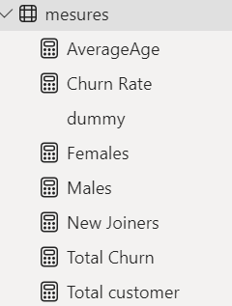

**Service table**

I have created separate service table because in the raw dataset customer have more than five service table so I joined together in single column to show the tooltip

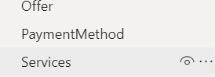

And also, I created one more column like churn status numerical column which is tell as 0 – stayed, 1- churned

**Maping Age group:**

I sorted the Age by

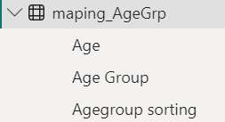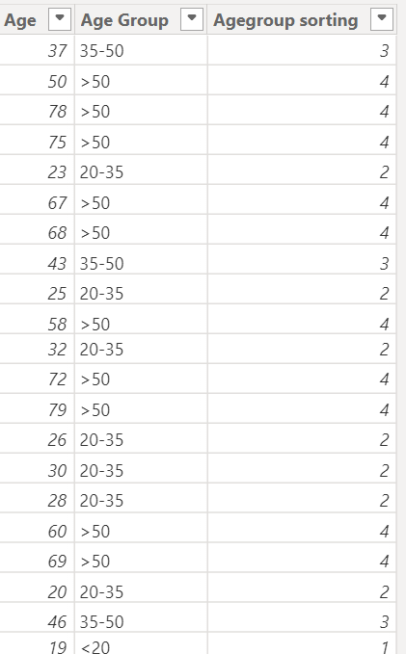

**Tenure Group Table:**

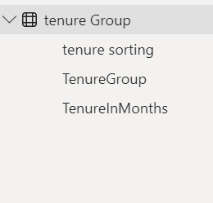

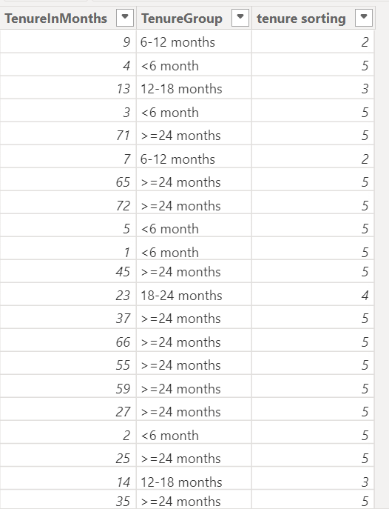

After completing all these I started for visualization

**Data modelling:**

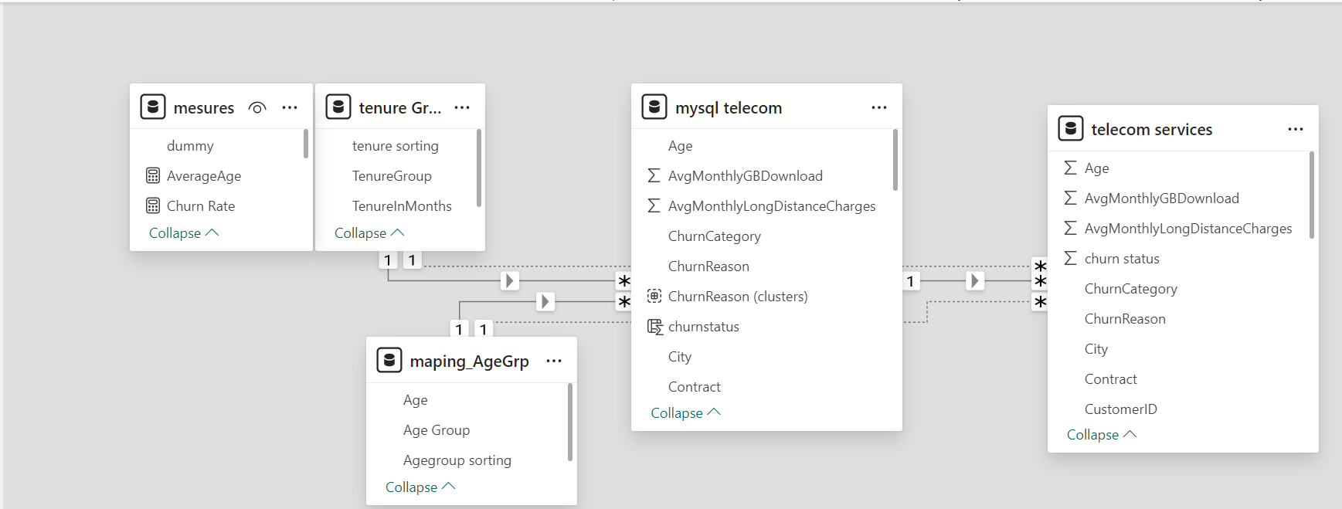

**Visualization**

1. **Index page:**

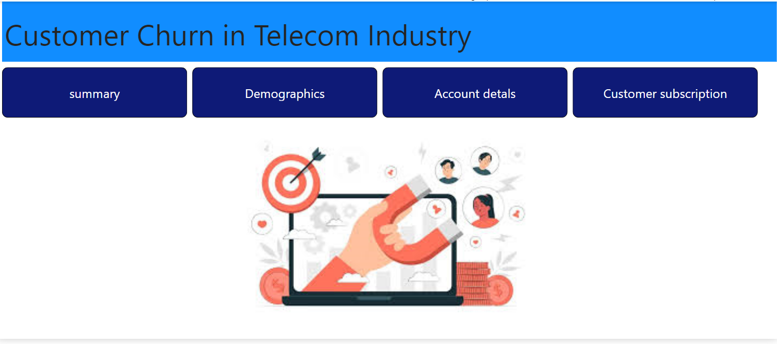

1. 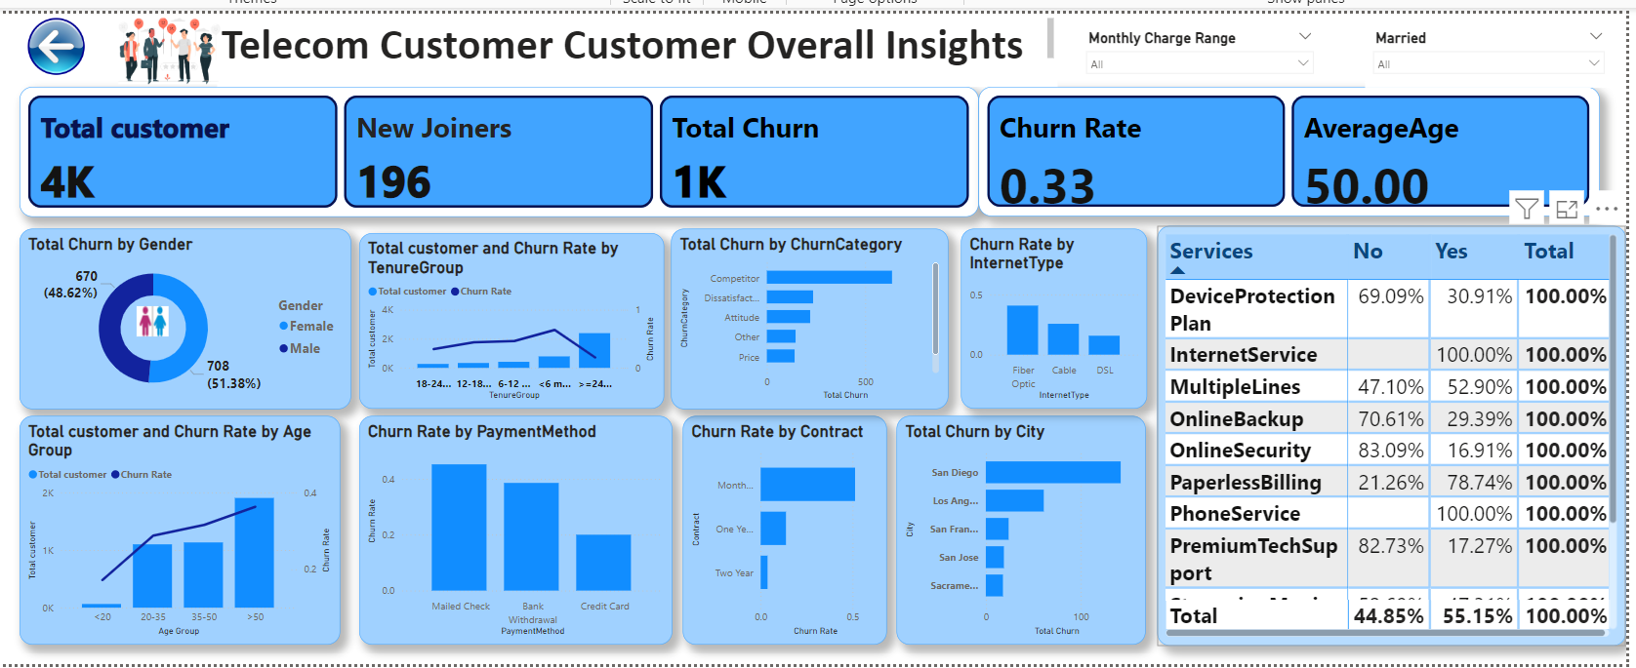**Summary page:**

The dashboard provides a comprehensive overview of the telecom customer data, highlighting key metrics and visualizing trends related to customer churn. Key elements include total customers, new joiners, churn statistics, and various factors influencing customer behaviours.

1. 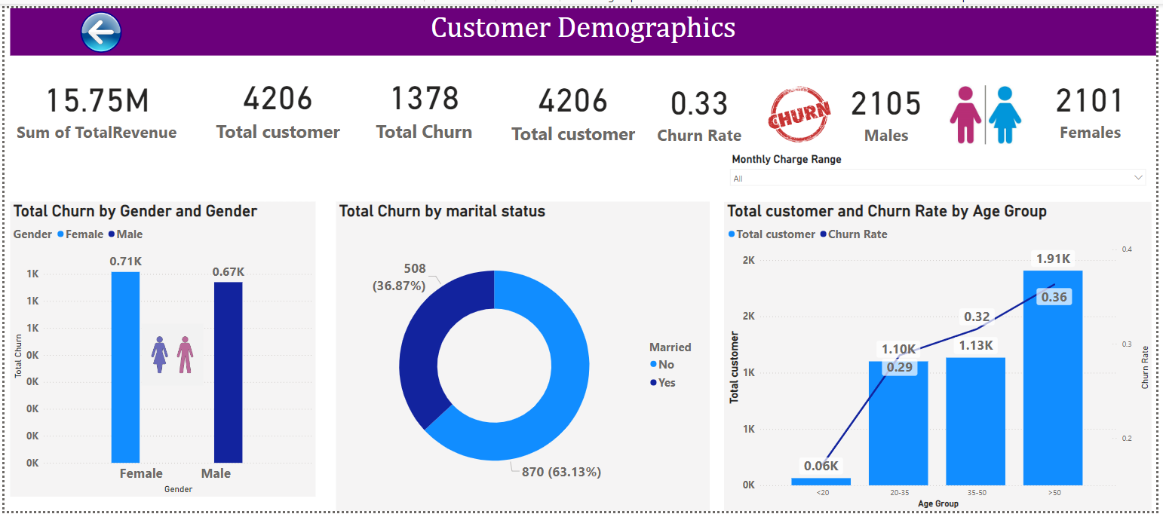**Customer Demographics:**

The dashboard provides a comprehensive overview of the telecom customer data, highlighting key metrics and visualizing trends related to customer churn. Key elements include total customers, new joiners, churn statistics, and various factors influencing customer behaviours.

1. **Account Details:**

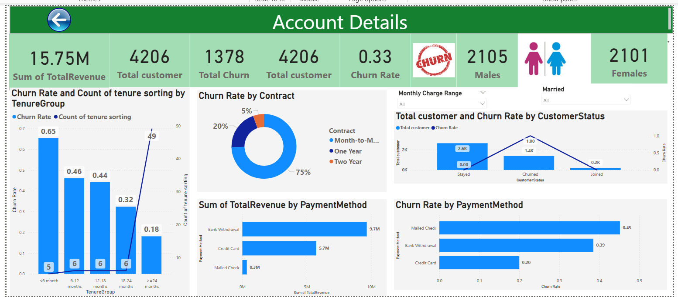

|  |
| --- |
| This visualization provides an in-depth analysis of account details, focusing on revenue, customer demographics, churn analysis by tenure and contract type, customer status, and payment methods. It helps in understanding the behaviour of different customer segments, identifying high churn areas, and analysing the effectiveness of various payment methods in retaining customers. |

1. **Customer Subscription:**

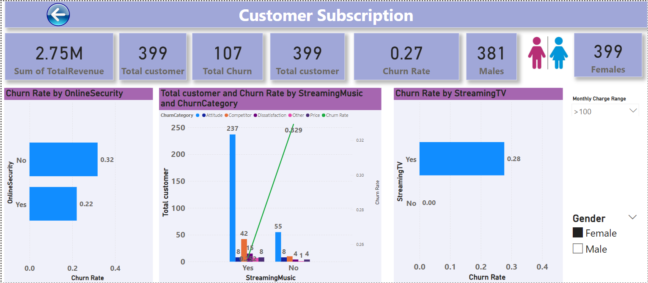

|  |
| --- |
| This visualization provides an in-depth analysis of customer subscription   * churn rate by online Security * Total customer and churn rate by streaming music and churn category * churn rate by the streaming TV. |

**Conclusion:**

This is my final capstone project. I have done this project getting knowledge from online resources. Before starting the project, data cleaning and analysing the data taking so much time finally, I got this visualization.

**Recommendations**

1. **Enhance Customer Satisfaction:**
   * Improve customer service, offer personalized solutions, and ensure high product quality.
2. **Implement Targeted Retention Strategies:**
   * Focus on high-risk groups with month-to-month contracts and certain payment methods, offering loyalty programs and incentives.
3. **Improve Service Quality and Adoption:**
   * Enhance high-churn services like Fiber optic internet and promote additional services through bundled packages.